**Snipped Complexity:**

**Two Nested For Loops:**

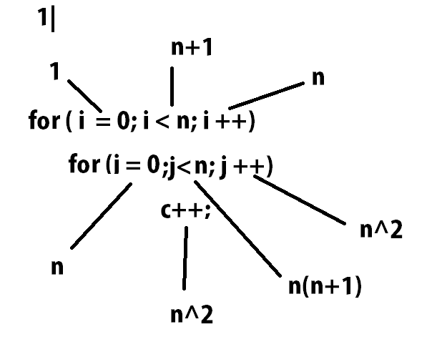

here, the highest complexity is in line 1 = n+1, line 2 = n(n+1), line 3 = n2

So, Total Complexity is, O(n2)

**Three Nested For Loops:**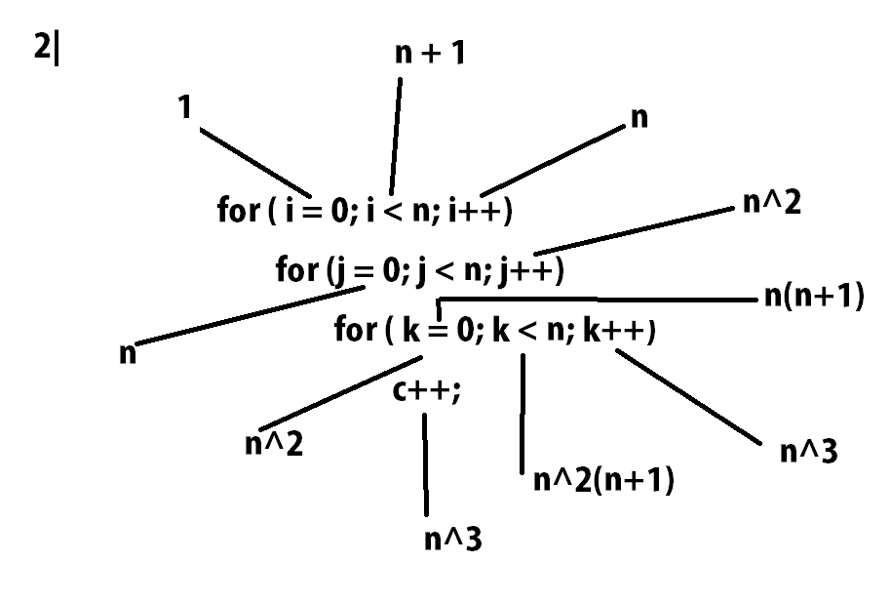

here, the highest complexity in , line 1 = n + 1, line 2 = n(n+1), line 3 = n2(n+1), line 4 = n3

So, The Total complexity is O(n3)

**Bubble Sort Algorithm:**

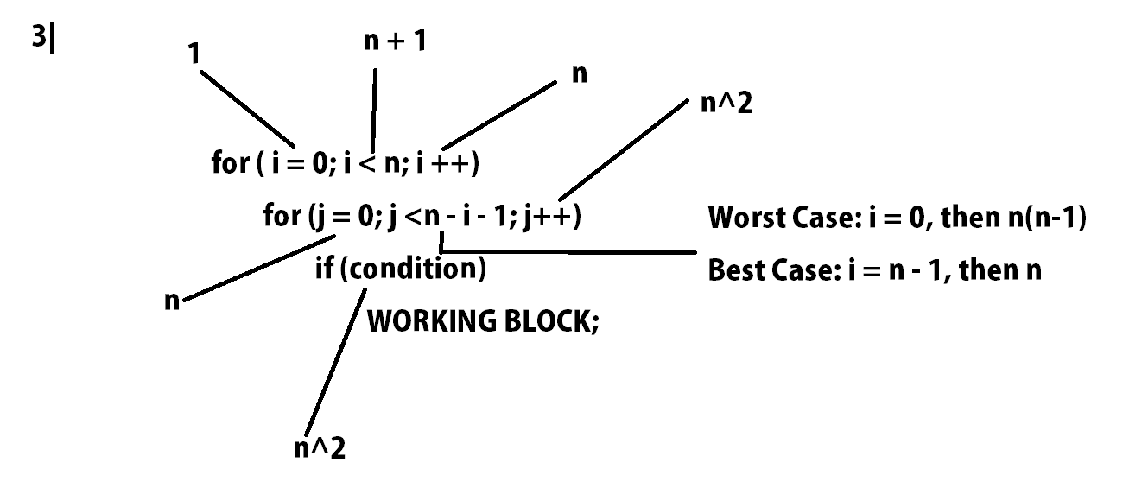Here, we will consider the worst case, So, The Complexity is O(n2)

**Insertion Sort Algorithm:**

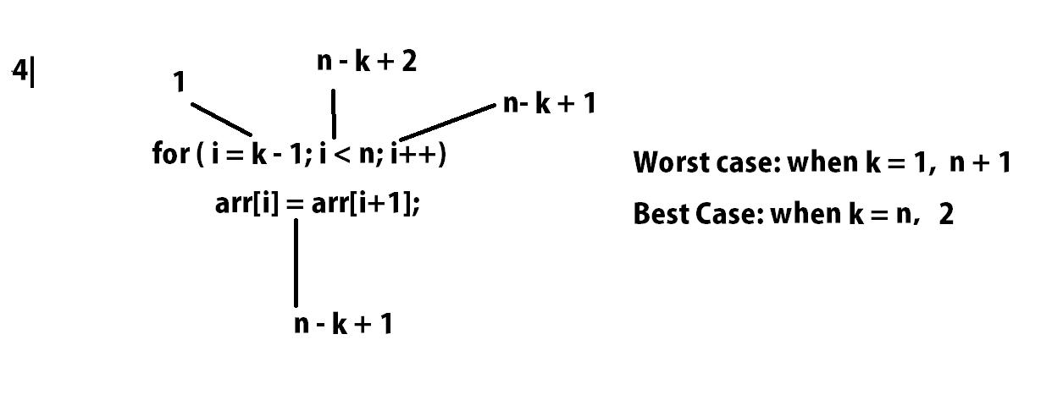

Here, we will consider the worst case, So, The Complexity is O(n)

**GCD & LCM:**

Let 10 & 20 be two numbers, So, we can write,  
 10 = 10 × 1,

20 = 10 × 2,

So, the if d = 10, a’ = 1, b’ = 2,  
The max that is 10 is the **GCD,**

Again, GCD × LCM = Multiplication of numbers

So, 20 is the **LCM.**

*Thank You!*